### We Will Drink a Slice form Cup of Kindness Yet, For Old Lang Syne

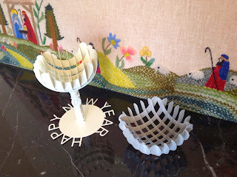

Slice form Cup and Bowl

It's time to sing Auld Lang Syne. Don't ask me what the song lyrics mean because they don't really make any sense. However, traditions abound and I will celebrate with my new slice form cup.  
  
First, I created a slice form bowl which I then transformed into the cup. (Isn't it amazing how things evolve from one design to another.) I have included instructions for both templates of a slice form bowl and the cup. I used a good quality cardstock as the slices need to be exact and there is little tolerance for hanging chads.

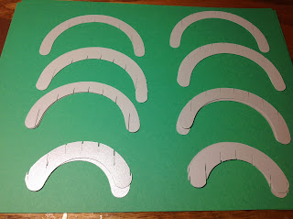

Arrange the pieces according to the slits

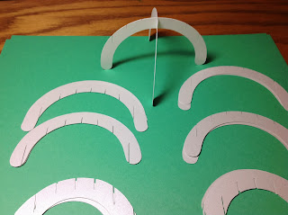

Do the largest piece first.

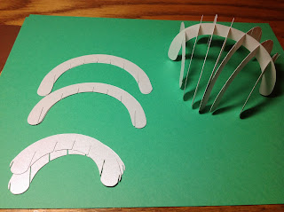

Do all of the slits in one direction and then in the other direction.

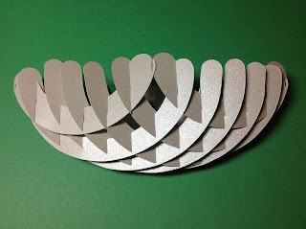

I love the way the bowl looks when it is lying flat,

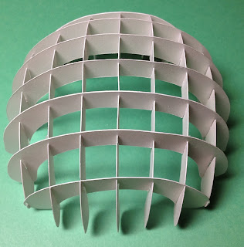

The underside pattern of the bowl...beautiful!

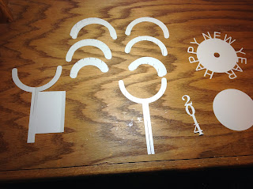

Here are the pieces for the cup.

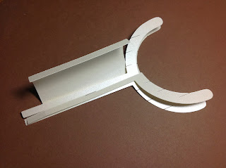

Insert the stem pieces and then train the paper to wrap around the stem.

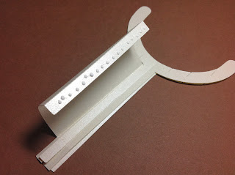

Glue as shown and fold the stem into a circle to produce the completed stem.

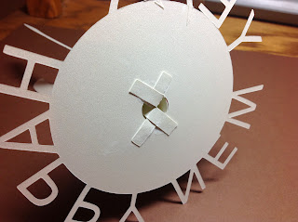

Insert into the whole in the circular base and fold the tabs as shown. Glue to the base.

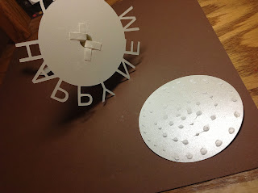

Put glue on the circle and attach to the base so that the bottom is sturdy.

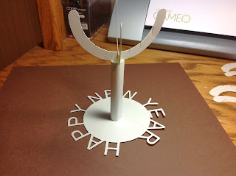

Make the bowl as shown previously.

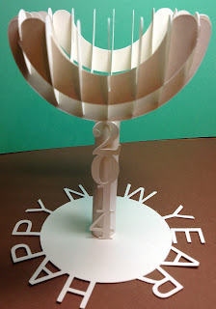

Completed Cup of Cheer...Happy New Year 2014!

Here are the lyrics for Auld Lang Syne so you can be as confused as I am about the meaning of the verses.

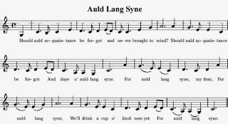

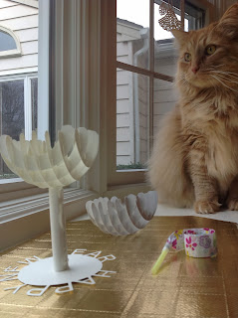

Marley's ready to celebrate the new year.

Happy New Year!

**Math for bowl:**

Spheres: x^2+y^2+z^2 = radius^2

Torus (for top edge): (Edge radius - sqrt(x^2+y^2)) ^2 + z^2 = tube radius^2

tube radius is one half of spacing between spheres